FOR IMMEDIATE RELEASE

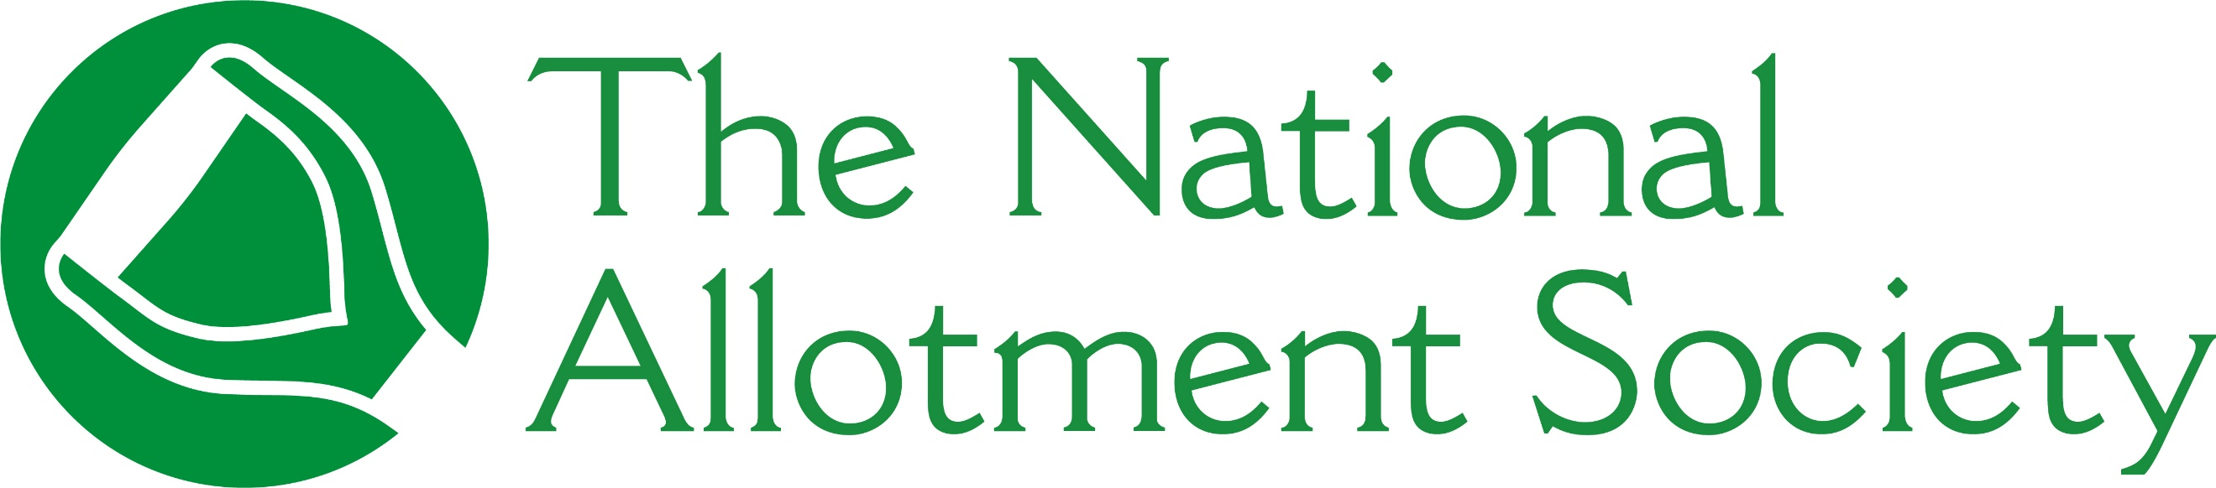

PRESS RELEASE

Monday 7th September, 2026

National Allotment Society launches new Joint Membership for households

The National Allotment Society (NAS), the UK’s leading representative for allotment holders, has launched a new Joint Membership option making it easier and more cost-effective for households to access NAS support, advice and member benefits.
Designed for two people living at the same address, Joint Membership allows two eligible individuals at the same address to share a single membership, recognising the growing number of plots being cultivated by couples, partners, friends or relatives, who often share the care of a plot and contribute jointly to allotment life.
The launch forms part of NAS’s continued commitment to supporting allotment holders, associations and sites across the UK, helping members access practical advice, legal guidance, insurance and representation at a time when growing spaces remain an important community resource.
Sonia Gallagher, National Secretary and General Manager at NAS, said: “Allotments are often enjoyed and cared for by more than one person, and our new Joint Membership offers better value for households while ensuring both members can access the advice, support and benefits that come with NAS membership, such as free liability insurance, initial legal support and expert advice.
“The new membership category also improves value for members and helps NAS gain a more accurate understanding of the number of individuals it represents, while also helping to demonstrate the scale and influence of the allotment community when working with government, local authorities, partners and other stakeholders.”
To find out more about the NAS and membership, visit https://thenas.org.uk/joinus

[ENDS]

Please direct any press enquiries to Emma Speirs on 01536 682800 or email emma.speirs@ballyhoo-pr.co.uk

NOTES TO EDITORS

Image credit: Shutterstock

NAS’ Joint Membership allows two eligible individuals at the same address to share a single membership

About the National Allotment Society
With over 133,000 members, The National Allotment Society (NAS) is the leading representative body for UK allotment holders. Its mission is to protect, promote and preserve allotments for future generations.

NAS works with allotment sites, associations, councils and individual plot holders to provide advice and guidance on a range of issues including site management, environmental concerns, tenancy agreements and fundraising.

For more information, go to https://thenas.org.uk/ or follow NAS on Facebook and Instagram

